**FACE RECOGNITION ARITIFICIAL INTELLIGENCE**

Using **PYTHON PROGRAMMING**

Report summited to

DR. A.P.J ABDUL KALAM TECHNICAL UNIVERSITY

FORMERLY UTTAR PRADESH TECHNICAL UNVERSITY,

LUCKNOW (UTTAR PRADESH) INDIA



**SESSION : 2022-23**

Submitted by:-

**UJJAWAL MALVIYA**

Roll no. :- **2101100100061**

**“ Department of Computer Science and Engineering”**

**Institute of Engineering and Rural Technology (IERT)**

Engineering Degree Division

26, Chaitham Lines, Prayagraj-211002(UP)

**DECLARATION**

We,declare that the report entitled “FACE RECOGNITION ATTENDANCE SYSTEM” is based on our own work carried out during the course of my study. I assert that the statement made and conclusion drawn are an outcome of the project work.

We further declare that to the best of my knowledge and belief that the report does not contain any part of the word which has been submitted for the award of any other degree/diploma/certificate in this university/deemed university of India or any other country.

UJJAWAL MALVIYA

ROLL NO. 210110010061

ACKNOWLEDGEMENT

I would like to express my sincerest gratitude to all those who have supported, encouraged, and helped me in completing this project. It has been a long and arduous journey, and I am deeply grateful for the help and support of everyone mentioned below.

First and foremost, I would like to thank my project mentor “**Ms. Divya Gupta”**mam& HOD of Department of Computer science **“Mr.Rohit Gupta”** sir, for their unwavering support and guidance throughout this project. Their expertise and keen eye have been invaluable in helping me to put together an impressive and comprehensive project. I am also thankful for their ongoing advice and feedback, which were essential in the completion of this project.

Ujjawal Malviya

Roll No.:- 2101100100061

CSE Department

IERT ,Prayagraj

Introduction to Python Programming

Python is a high-level, object-oriented programming language that is considered to be easy to learn and use. It is used to create software applications, websites, and scripts. Python's syntax is simple and straightforward, and its code is often shorter and easier to read than code written in other languages. Python also has a wide range of libraries, tools, and frameworks that can help developers create more complex software applications more quickly. With its versatility, scalability, and compatibility, Python is a great choice for developers of all levels

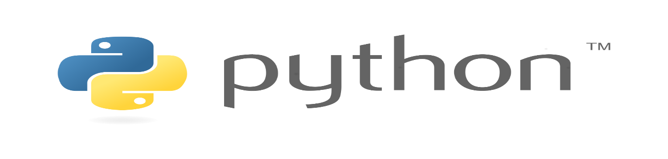

[This Photo](https://communityblog.fedoraproject.org/help-port-python-packages-to-python-3/) by Unknown Author is licensed under [CC BY](https://creativecommons.org/licenses/by/3.0/)

History of Python

Python was first released in 1991 by Guido van Rossum, a Dutch programmer. Initially, Python was created as an easy-to-read scripting language and has since evolved into a powerful and popular general-purpose programming language.

Python's development started as a hobby project for van Rossum and it was released to the public in 1991. The language was designed to be easy for beginners to learn and be as close to English as possible. Python was inspired by the ABC language, which was developed by van Rossum in the 1980s. The initial version of Python, 0.9.0, was released in 1991.

Python 2.0 was released in 2000, and added several new features including support for Unicode and the addition of list comprehensions. Python 3.0 was released in 2008, introducing several new features such as the new print statement and a new string formatting method. Python 3.0 is currently the newest version, but Python 2.7 is still widely used.

Python has since become a popular programming language due to its simple syntax and easy-to-read code. It is used in many applications including web development, scientific computing, and data analysis. Python is also widely used in artificial intelligence, machine learning, and natural language processing

**Python Syntax**

Python syntax is a set of rules which define how a Python program will be written and understood by the interpreter. It specifies how to structure the program and how to write the code. It also determines how the program will be interpreted by the interpreter.

Python semantics refers to the meaning of the code and how the Python interpreter understands it. It is the set of rules that define how the code is evaluated. This includes the meaning of variables, functions, and class definitions.

Python syntax is relatively straightforward and easy to understand. It contains a wide variety of built-in data types, such as lists, strings, tuples, dictionaries, and numbers. It also has a variety of control structures, such as loops, conditionals, and exceptions. Python also offers a variety of operators for manipulating data, such as arithmetic, comparison, and logical operators.**Python Indentation**

Indentation refers to the spaces at the beginning of a code line.

Where in other programming languages the indentation in code is for readability only, the indentation in Python is very important.

Python uses indentation to indicate a block of code.

**Python’s built in Data Types-**

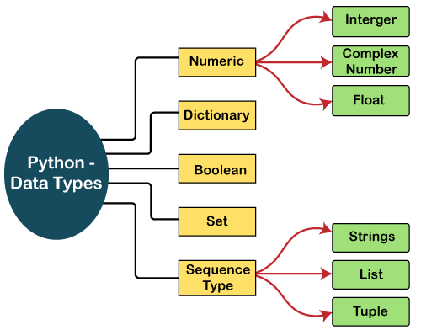

• **Integers** – This value is represented by int class. It contains positive or negative whole numbers (without fraction or decimal). In Python there is no limit to how long an integer value can be.

• **Float** – This value is represented by float class. It is a real number with floating point representation. It is specified by a decimal point. Opt ionally, the character e or E followed by a

Positive or negative integer may be appended to specify scientific notation.

• **Complex Numbers** – Complex number is represented by complex class. It is specified as (real part) + (imaginary part)j. For example – 2+3j

• **String** - Strings are arrays of bytes representing Unicode characters. A string is a collection of one or more characters put in a single quote, double-quote or triple quote. In python there is no character data type, a character is a string of length one. It is represented by str class.

• **List** - Lists are just like the arrays, declared in other languages which is a ordered collection of data. It is very flexible as the items in a list do not need to be of the same type.

• **Tuple** - Tuple is also an ordered collection of Python objects. The only difference between tuple and list is that tuples are immutable i.e. tuples cannot be modified after it is created. It is represented by tuple class.

• **Bool** - Data type with one of the two built-in values, True or False. Boolean objects that are equal to True are truthy (true), and those equal to False are falsie (false). But non Boolean objects can be evaluated in Boolean context as well and determined to be true or false. It is denoted by the class Bool.

• **Set** - In Python, Set is an unordered collection of data type that is iterable, mutable and has no duplicate elements. The order of elements in a set is undefined though it may consist of various elements.

• **Dictionary** - Dictionary in Python is an unordered collection of data values, used to store data values like a map, which unlike other Data Types that hold only single value as an element.

**Why Python?**

• Python works on different platforms (Windows, Mac, Linux, Raspberry Pi, etc).

• Python has a simple syntax similar to the English language.

• Python has syntax that allows developers to write programs with fewer lines than some other programming languages.

• Python runs on an interpreter system, meaning that code can be executed as soon as it is written. This means that prototyping can be very quick.

• Python can be treated in a procedural way, an object oriented way or a functional way.

**Library in Python**

Python has created several open-source libraries, each with its root source. A library is an initially merged collection of code scripts that can be used iteratively to save time. It's similar to a physical library in that it holds reusable resources, as the name implies. A Python library is also a group of interconnected modules. It contains code bundles that can be reused in a variety of programs.

**How Python Libraries work?**

A Python library is merely a bunch of code scripts or modules of codes that we can utilize in a program for specific operations, as stated above. We use libraries to don't have to rewrite code already written in our program. However, here's how it works. The library files have a DLL extension in the MS Windows environment (Dynamic Load Libraries). When we import a library to our program and run it, the linker looks for that library automatically.

**Standard Libraries of Python**

Python's syntax, semantics, and tokens are all contained in the Python Standard Library. It comes with built-in modules that give the user access to basic functions like I/O and a few other essential modules. The Python libraries have been written in the C language for the most part. There are over 200 core modules in the Python standard library. Python is a powerful programming language because of all of these factors.

The biggest strength of Python is huge collection of standard library which can be used for the following

➢ Machine Learning

➢ GUI Applications (like Tkinter, PyQt etc.)

➢ Web frameworks like Django (used by YouTube, Instagram, Dropbox)

➢ Image processing (like OpenCV, Pillow)

➢ Text processing and many more..

ARTIFICIAL INTELLIGENCE

->Artificial intelligence (AI) refers to the simulation of human intelligence in machines that are programmed to think like human sand mimic their actions.

-> The ideal characteristic of artificial intelligence is its ability to rationalize and take actions that have the best chance of achieving a specific goal.

->A subset of artificial intelligence is machine learning (ML), which refers to the concept that computer automatically learn from and adapt to new data without being assisted by humans.

-> Deep learning techniques enable this automatic learning through the absorption of huge amounts of unstructured data such as text, images, or video.



**ABOUT CNN(CONVOLUTIONAL NEURAL NETWORK) :**

**->**CNN has wide application in image and vedio recognition.

->CNN,like neural neural network are made up of neurons with learnable weight and biases.

->Each neuron receives several inputs , takes a weighted sum over them, pass it through an activation function and responds with an output.

**ABOUT PMI(python imaging library) :**

-> PIL stands for Python Imaging Library, and it’s the original library that enabled Python to deal with images. PIL was discontinued in 2011 & support python 3.

-> If you want to deal with images directly then you can use NumPy and SciPy. Other libraries for image processing are OpenCV. these libraries are faster and more powerful than Pillow

**FACE RECOGNITION :**

->The face – unique part

-> For face recognition there are two types of comparison ¬

1.**Verification.** This is where the system compares the given individual withwho that individual Says they are and gives a yes or no decision.

2.**Identification** This is where the system compare the given individual to all other individual in the databases and gives a ranked list of matches.



**BIBLIOGRAPHY:**

Prepared by UJJAWAL MALVIYA Department of Computer Science and Engineering Institute of Engineering And Rural Technology Prayagraj, Uttar Pradesh, India 2021-2025

**REFERENCES:**

¬ <HTTPS://WWW.GEEKSFORGEEKS.ORG/>

¬ <HTTPS://BOOTCAMP.AIFORYOUTH.ORG/>

¬HTTPS://WWW.INTEL.COM/CONTENT/WWW/US/EN/CORPORATE/ARTIFICIAL-INTELLIGENCE/DIGITAL-READINESS-AI-FOR-YOUTH.HTML